RECONSIDERING RENAISSANCE HUMANISM:
CYNICS, FOOLS, AND PROPHETS PROFITS
ROML 8000 Pendergrass/SPAN 8010 Bultman (9:30-10:45 T/TH) SPRING 2018*

Is it accurate to assume that the classic texts of Renaissance Humanism transmit archaic concepts of human nature and existence? To answer this question, and to more expertly discuss our potentially posthumanist present and future (Wolfe 2009), this course contends we would do well to first taste the sarcastic laughter and biting critiques of Erasmus, Rabelais, and Jesuit philosopher Baltasar Gracián. These consummate stylists were deeply engaged with the paradigm changes in early modern institutions and social practices that created the conditions for Enlightenment culture. In addition to The Praise of Folly, the Third Book of Pantagruel, and Oráculo manual [the Pocket Oracle], we will read selections from Alfonso de Valdés’s witty Diálogo de Mercurio y Carón [Dialogue of Mercury and Charon], Montaigne’s innovative essays, and Quevedo’s neo-Stoic Sueños [Dreams]. Fragments of writings by Petrarch, Boccaccio, Pico della Mirandola, Ficino, Machiavelli, Vives, Thomas More, Montaigne, and Descartes will provide a broad base for our examination of the intellectual and literary practices that spread from Italy to Western Europe from the 14th to the 17th century. This foundation will allow us to trace the concepts of the human that survived the turmoil of the Reformation and Counter-Reformation to become conventional and mainstream. It will also allow us to identify the crucial oppositional discourses—baroque in their monstrous and utopian nature—that were repressed. How did the rise of philosophical rationalism serve to banish religious superstition and promote modern science? What rhetorical and technical sleights-of-hand did the emergent political forces of capitalist colonialism use to misappropriate Renaissance Humanism and relegate all but educated, European males to subservient status?

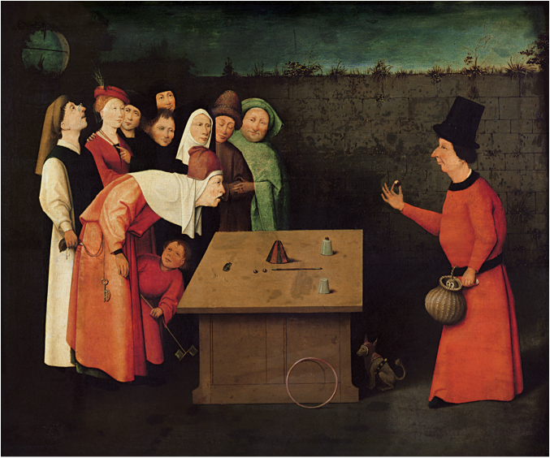
The Conjurer by Hieronymus Bosch/Bosch’s workshop (1502)

*ROML and SPAN groups will meet together in English with regular breakout sessions. Breakouts, assignments, and some readings for SPAN will be in Spanish and for ROML in English or French.

